Assignment 3.1 Rossler Gian Karlo Boquiren

Part 1:

List all the American Bully

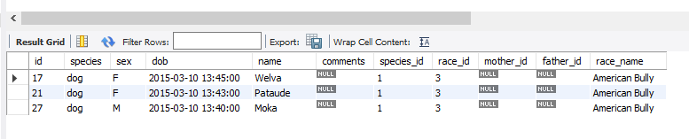

List all the animals (name, dob, race) who don’t have the word color in their race description.

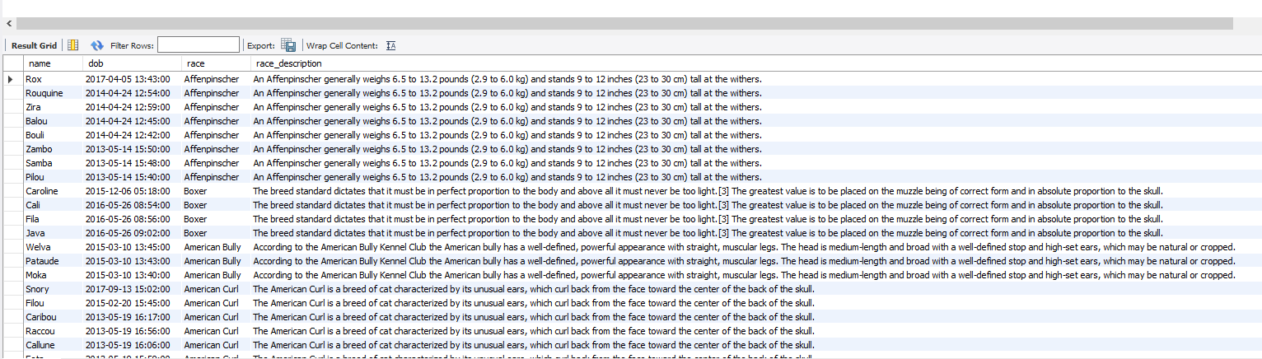

Part 2:

List all the Cats and Parrots with their sex, species, Latin name, and race if exist. Order by animal type and race.

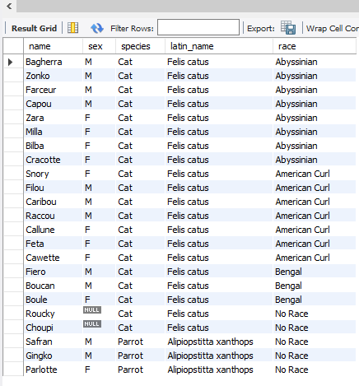

List the female dogs who do not race and were born before July 2016. (name, dob, and race)

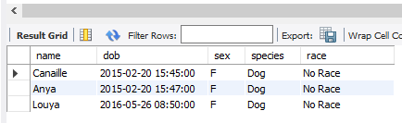

Part 3:

List all the Cats who have parents (name and parent’s name)

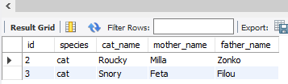

List all Bouli’s kids (name, sex, and dob)

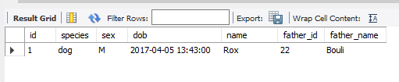

List all the animals that have a father, a mother, and a race. We must know the parent’s race. (name, parents name, race name)

